

**PRESS RELEASE** Prague, 24 September 2018

# Building D in BB Centrum has a new look

[**PASSERINVEST GROUP**](http://www.passerinvest.cz/)**, a.s., the leading Czech development and investment company, is successfully continuing with the revitalisation of the** [**BB Centrum**](http://www.bbcentrum.cz/) **buildings. This September saw the completion of the reconstruction of Building D, begun in January 2018. Thus, the building from the year 2002 offering 4000 m2 of office space on six floors offers its tenants even greater comfort in above-standard spaces thanks to technological improvements.**

[Building D from the atelier of architect](http://www.bbcentrum.cz/cz/o-nas/bb-centrum/realizovane-projekty/budova-d) Kordovský and lying in the southwest section of BB Centrum has undergone renovations according to a project by the architects Michal Bernart and Igor Hobza from Momon. According to their designs, both of the relaxing rooftop terraces, north and south, were reconstructed and the upper part of the building was cladded in metal lath. But the changes primarily concern the interiors. The most significant change to the original interior design of the project is the reconstruction of the reception and entrance lobby and the replacement of the original sliding doors with revolving doors. The complete renovations also applied to all the sanitary facilities in the building, a new coating of plaster was applied to the garages, the output of the ventilation was increased and the elevators will be replaced.

*“BB Centrum is constantly developing and trying to provide its tenants the highest standard and the best facilities. All of the reconstruction is in this spirit. The just upgraded Building D, which we purchase back in March 2017, has thus become a modern building fulfilling the high demands on a functional, but comfortable work environment,”* commented Radim Passer, the Chairman of the Board of Directors of PASSERINVEST GROUP, a.s., with regard to the revitalisation.

The overall expenses for the reconstruction of Building D have reached 50 million crowns. But the invested funds promise a quick return, because the building is already almost completely occupied and only the last 305 m2 of office space on the first floor is available to rent.

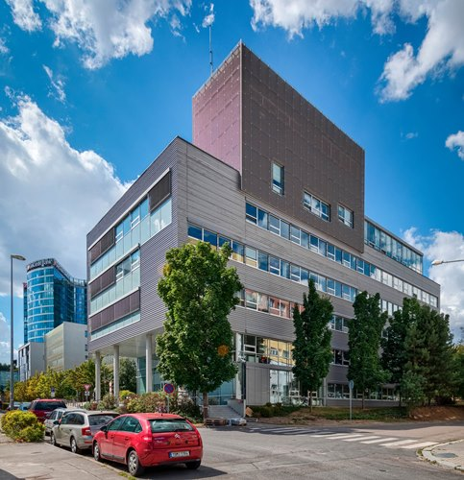

Reconstructed Building D in BB Centrum in Prague 4

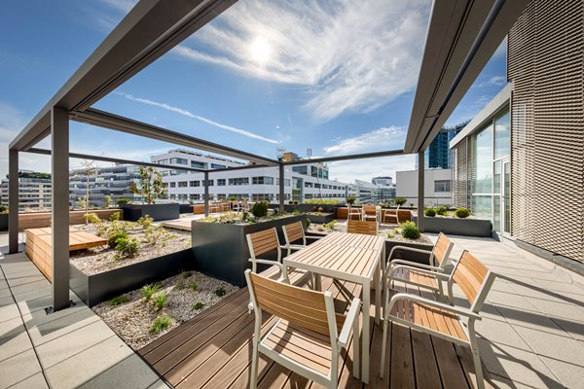

Revitalised terrace of Building D in BB Centrum in Prague 4

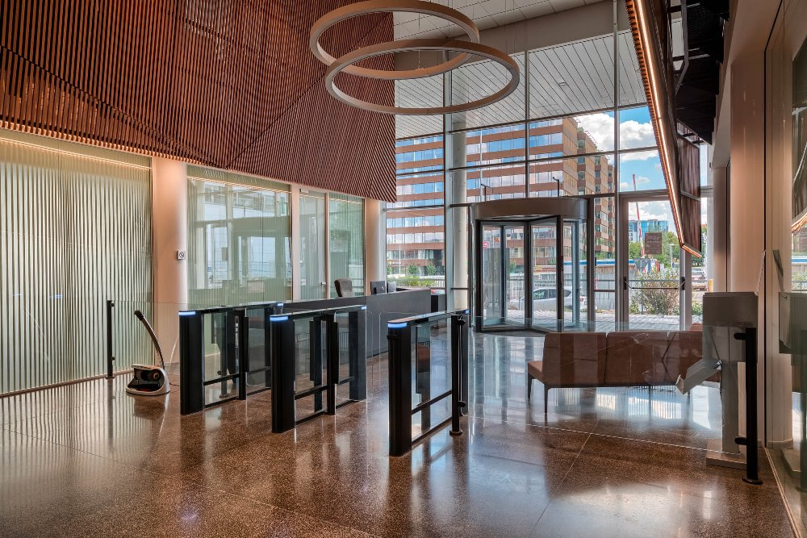

New entrance and reception of Building D in BB Centrum in Prague 4

You can get more information and photographs in print quality from:

Kristýna Samková**,** Head of PR and Marketing Department

**PASSERINVEST GROUP, a.s.**

Tel.: (+420) 221 582 111

Mobil: (+420) 602 186 708

E-mail: [Kristyna.Samkova@Passerinvest.cz](mailto:Kristyna.Samkova@Passerinvest.cz)

www.passerinvest.cz, [www.bbcentrum.cz](http://www.bbcentrum.cz)

Marcela Štefcová

**Crest Communications a.s.**

Mobil: (+420) 731 613 669

E-mail: marcela.stefcova@crestcom.cz

**About the developer**

**PASSERINVEST GROUP**, a. s., is a purely Czech development and investment company, whose name is primarily connected with the realisation of the multifunctional **BB Centrum** complex in Prague 4 – Michle. The company, established by Radim Passer in 1991, built a very good reputation both on a local and international level with this, the most successful and extensive project of its kind in Central Europe. This is not only to the credit of the quality of the realised projects and the high level of the provided services, but also due to the sense of fair play, an accommodating relationship to the buildings’ tenants/users and responsibility to the society and the environment. **PASSERINVEST GROUP** also has other interesting development projects in its portfolio.